Something is wrong!




upside down



back to front

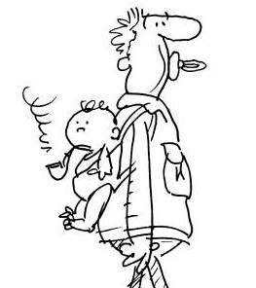

inside out wrong way round
(au contraire)

Suggested Songs:
“Upside Down” by Diana Ross
https://www.youtube.com/watch?v=WcpsQhwtvwU
“Upside Down” by Jack Johnson
https://www.youtube.com/watch?v=CrSNT9B7ZA8

